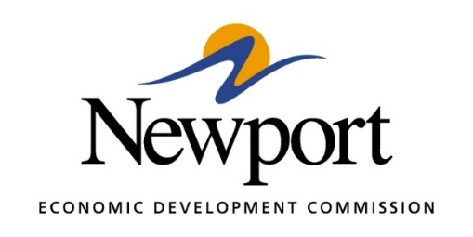

AGENDA
November 14, 2024

- Open Meeting

- Approval of Minutes Last Meeting – Vote Required

- Approval of Financial Report – Vote Required
  - Obligations – Information
  - Sales Tax Collections - Information

- 2025 Budget – Vote Required

- Executive Director’s Report – Information

- Director of Chamber Affairs Report – Information

- ReNewport Grants – Vote Required
  - Taylor Kimbrough Funeral Home

- Childcare Facility – Information
  - NEDC - Renovations to the Building

- DriveSmart Update – Information

- Retail Academy – Information

- 75 Strong – Information

- B2Scale Grant with CORI – Information

- Gen4Jets - Information

- Industrial Greenhouse -Information

- Tech Depot Events – Information
  - Performance Report

- New Downtown Parking Lot – Information

- P3 Group Housing Update – Information

- Project Clippings – Information

- Project Rice Straw – Information

- Project Junior Varsity - Information

- Prospect Crush – Information

- Prospect Splice – Information

- Prospect Char – Information

- Project Save – Information

- Project Scooby Doo - Information

- Adjourn

