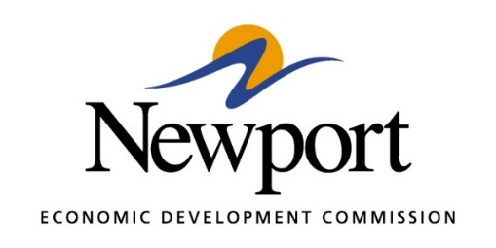

AGENDA
December 12, 2023

- Open Meeting

- Approval of Minutes Last Meeting – Vote Required

- Approval of Financial Report – November

- Executive Director’s Report – Information

- Director of Chamber Affairs Report – Information

- ReNewport Grants – None at this Time

- Tech Depot Events – Information
  - Grand Opening
  - Major Donors Reception
  - ACT Bootcamp

- Center on Rural Innovation – Information
  - The Center on Rural Innovation (CORI) is a 501(c)(3) nonprofit organization partnering with rural leaders across the country to build tech economies that support scalable entrepreneurship and lead to more tech jobs in rural America.
  - Established in 2017, CORI is at the heart of a dynamic social enterprise focused on closing the rural opportunity gap. To maximize all possible resources to address this critical problem, the organization partners with a taxable nonprofit, Rural Innovation Strategies, Inc. (RISI), and a seed fund, CORI Innovation Fund (CIF), focused on early-stage technology companies located in rural areas.

- DriveSmart Lease – Information
  - NEDC Building Lease
  - Iron Mountain Train Depot Lease

- Project BioTech – Information
  - Anticipate decision in late December or early Janauary

- Tech Depot Non-Profit Status Consideration – Information or Vote Required
  - See the attached proposed bylaws.

- Daycare Update, Early Years Place – Information

- P3 Group Housing – Information

- 12 Days of Christmas – Information

- DC Rapid Electric Vehicle Charger – Information

- Rock N Roll Hwy Museum - Information

- Adjourn

