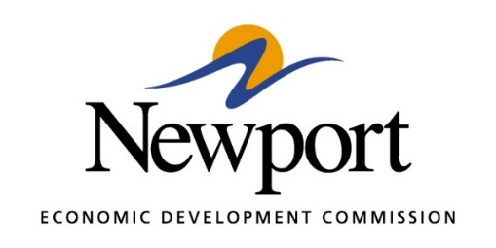

AGENDA
AUGUST 8, 2023

- Open Meeting

- Approval of Minutes Last Meeting – Vote Required

- Approval of Financial Report – Vote Required

- Executive Director’s Report – Information

- Director of Chamber Affairs Report – Information

- ReNewport Grants – Vote Required

- Medical Marijuana Settlement Fund Requests – Vote Required
  - Committee A Recommendation - Funding Under the Rainbow with a $10,000 grant for furniture and equipment from the Medical Marijuana Funds.

- Medical Marijuana Process Recommendation – Vote Required
  - Committee A Recommendation – NEDC would advertise that the Newport Economic Development Commission is using $50,000 from the Medical Marijuana Settlement for additional grants for non-profit organizations in Jackson County and is accepting applications. This would be done on Facebook and through the NEDC and the Chamber Constant Contact email databases. Applications would be due on September 1st and Committee A would review the applications and make recommendations to the entire Commission at the September meeting. If choices need to be made between applications, preference will be given to organizations with consistency to that serve a larger number of people and that have a proven track record in the community. We will not put the limit in the advertisement, but the top limit will remain $10,000.

- Prospect Ring Ring – Vote Required
  - Committee C Recommendation - The following is recommended: Incentives for Project Ring Ring. The Committee is recommending that the NEDC put in $500,000 to match the anticipated $2,000,000 grant from EDA. We will either put the cash in at the time of construction, or the prospect can put the cash in at the time of construction and we can reduce their rent by $100,000 per year for the first five years. The company can choose the approach that will work best for them. This will be the NEDC’s total cash commitment to this project.

- Newport Speedway – Vote Required
  - Committee B Recommendation - The committee proposes that the lease with the Newport Speedway be amended to cancel the lease payment for 2022 ($10,000) and half the lease payment for 2023 ($5,000) and allow that $15,000 to go toward the sewer project. The lease payments will resume in 2024 with payments as follows: $11,000 per year for 2024 through 2029 (to make up the $5,000 from 2023), and $10,000 per year for 2030 – 2032. The group would also request regular reports about racing activity and would encourage Newport Speedway to pay the lease in payments during the year rather than one lump sum.

- Tech Depot Non-Profit Status Consideration – Information (Vote at Future Meeting)

- Gränges Update – Information

- Daycare Update, Early Years Place – Information

- Division of Workforce Services TANIF Grant – Information

- Delta Regional Authority Grant – Information

- EDA Grant for Prospect Ring Ring - Information

- P3 Group Housing – Information

- Prospects Update – Information

- Senior Citizens Center - Information

- Adjourn

