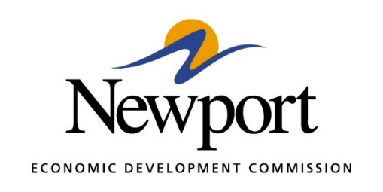

AGENDA
September 13, 2022

- Open Meeting

- Approval of Minutes Last Meeting – Vote Required

- Approval of Financial Report – Vote Required

- Executive Director’s Report – Information

- Director of Chamber Affairs Report – Information

- ReNewport Grants – None to Date

- Signage for the NEDC Building – Information

- Outdoor WiFi Accessibility Park Ribbon Cutting– Information

- Tech Depot Construction – Information

- Tech Depot A+ Classes at Night – Information

- Prospect Proposal – Information

- Prospect Proposal – Information

- Postmaster Spirits - Information

- White River Regional Port Authority – Information/Discussion

- Rail Spur to Airbase Industrial Park - Information

- Adjourn

