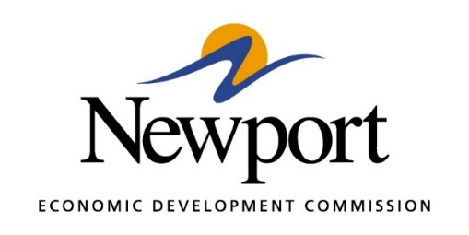

AGENDA
April 13, 2021
Meeting in Person at the NEDC or By Phone
- Open Meeting

- Approval of Minutes – Vote Required

- Approval of Financial Report – Vote Required

- Executive Director’s Report – Information

- Director of Chamber Affairs Report – Information

- ReNewport Grants – None at Time of Agenda

- Tech Depot Classes – Information

- Tech Depot Construction – Information

- Medical Marijuana Issue – Information

- Website Upgrade – Information

- Newport Drag Strip Proposal – Vote Required

- Prospect Data – Information

- Legislative Issues – Information

- Adjourn

