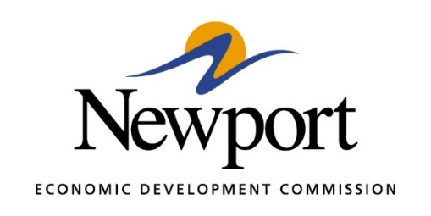

AGENDA
January 12, 2021
Meeting in Person at the NEDC or By Phone
- Open Meeting
- Approval of Minutes – Vote Required
- Approval of Financial Report – Vote Required
- Executive Director’s Report – Information
- Director of Chamber Affairs Report - Information
- ReNewport Grants – None at Time of Agenda
- Amended 2020 Budget – Vote Required
- Tech Depot Classes – Information
- ADWORC Program at Tech Depot - Information
- Tech Depot Construction – Information
- Project Protection 2032 – Information
- Project Secure Tech 2022 – Information
- Entergy Support Letter Formula Rate Plan Rider – Information
- Medical Marijuana Issue – Information
- Second Round of COVID Relief (Including PPP) – Information
- Adjourn

