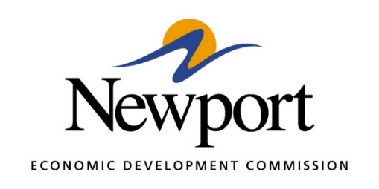

AGENDA
December 8, 2020
Meeting in Person at the NEDC

- Open Meeting
- Approval of Minutes – Vote Required
- Approval of Financial Report – Vote Required
- Executive Director’s Report – Information
- Director of Chamber Affairs Report - Information
- ReNewport Grants – Vote Required
  - Blue Bridge Brews & Bakery
  - Jones Home Furnishings
- Natural State Wellness - Information
- Tech Depot Project – Information
- Property Transformation Project – Information
- Prospect 2031 – Project Sparkle - Information
- Prospect 2028 – Project Secure - Information
- Retail Strategies Prospect - Information
- Adjourn

