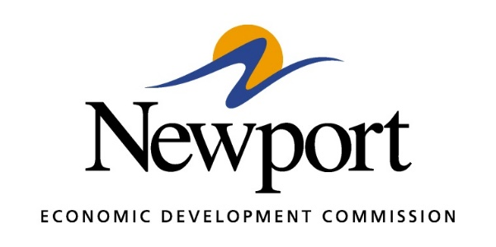

AGENDA
November 12, 2019
Meeting at Newport Economic Development Commission Office
- Open Meeting
- Approval of Minutes
- Approval of Financial Report
- Executive Director’s Report
- Director of Chamber Affairs’ Report
- ReNewport Grants
- ACT Workready Community
- Clean Up Project Properties for Consideration
- Prospect Incentive Proposals
- Annual Strategic Plan Draft
- Annual Budget
- Election of Officers
- Employee Review (Closed Session)
- Actions Based on Employee Review (If Any Are Necessary)
- Adjourn Meeting

