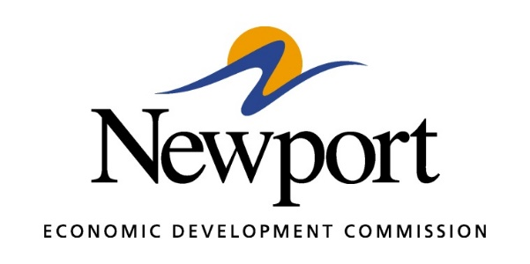

AGENDA
THURSDAY – August 15, 2019
Meeting at Newport Economic Development Commission Office
- Open Meeting
- Approval of Minutes
- Approval of Financial Report
- Executive Director’s Report
- Director of Chamber Affairs’ Report
- ReNewport Grants
- Taylor Made Ambulance Job Expansion
- ACT Workready Community
- Access to Capital Seminar
- Certified Sites Program
- Medical Marijuana Update
- Lighting Proposal
- Solar Companies
- Adjourn Meeting

