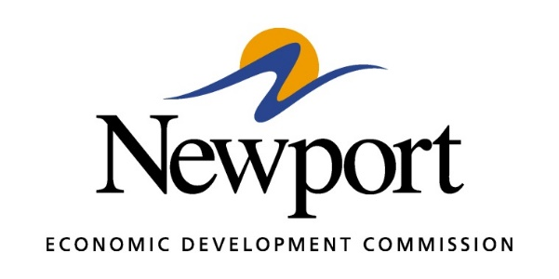

AGENDA
March 14, 2019
Meeting at Newport Economic Development Commission Office

- Open Meeting
- Approval of Minutes
- Approval of Financial Report
- Executive Director’s Report
- Director of Chamber Affairs’ Report
- ReNewport Grants
- Medical Marijuana Update
- Ever Corporation Property
- Prospect Activity
- MOST Update
- LeadAR Visit
- EDA Grant Potential
- DRA Infrastructure Grant
- Adjourn Meeting

