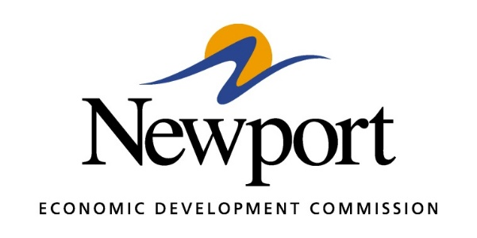

AGENDA
November 8, 2018
Meeting at Unity Health Harris Medical Center Community Room
- Open Meeting
- Approval of Minutes
- Approval of Financial Report
- Executive Director’s Report
- Director of Chamber Affairs’ Report
- ReNewport Grants
- Ever Corporation Property
- Job Fair Recap
- Medical Marijuana
- Maverick House
- Library Proposal
- MOST Update
- Staff Review and Compensation
- 2019 Budget
- 2019 FOCUS Plan
- NEDC Officers for 2019
- Adjourn

