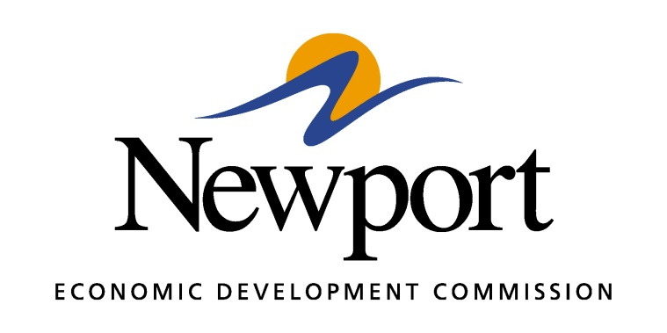

AGENDA
July 12, 2018
Meeting Held at Arkansas Steel Associates
- Open Meeting
- Approval of Minutes
- Approval of Financial Report
- Executive Director’s Report
- Director of Chamber Affairs’ Report
- ReNewport Grants
- Core Distinction Group
- Mega Site Certification
- Wage and Benefits Survey
- 100 Acre Site Certification
- Ever Corporation Property
- Retail Strategies
- Adjourn

