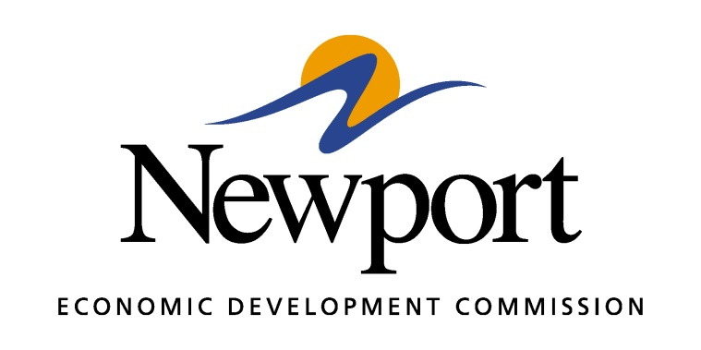

AGENDA
June 14, 2018
Meeting Held at NEDC Offices
- Open Meeting
- Approval of Minutes
- Approval of Financial Report
- Executive Director’s Report
- Director of Chamber Affairs’ Report
- ReNewport Grants
- New Employee
- Core Distinction Group
- Wage and Benefits Survey
- Mega-Site Certification
- 100 Acre Site Certification
- Non-Resident Employee Survey
- Night at the Ballgame
- White River Port Prospect
- Adjourn

