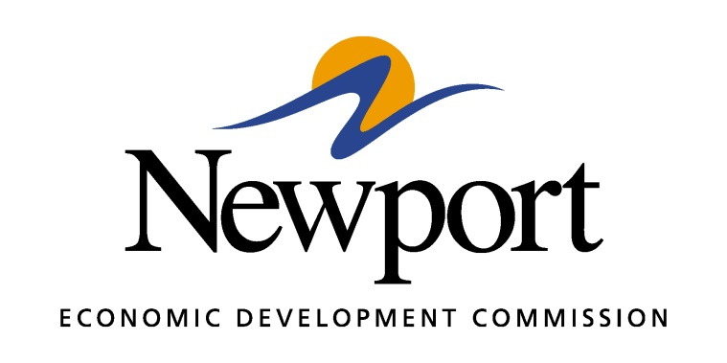

AGENDA
April 12, 2018

Meeting Held at NEDC Office

- Open Meeting
- Approval of Minutes
- Approval of Financial Report
- Executive Director’s Report
- Director of Chamber Affairs’ Report
- ReNewport Grants
- Medical Marijuana Process
- Recent Prospect Quote
- Competitive Communities Initiative
- Website
- Broadband Grants Available
- Adjourn

