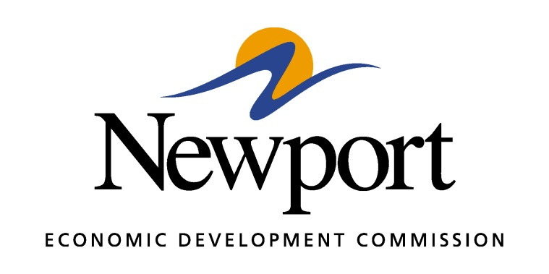

AGENDA
March 8, 2018

Meeting Held at ASU-Newport

- Open Meeting
- Approval of Minutes
- Approval of Financial Report
- Executive Director’s Report
- Director of Chamber Affairs’ Report
- ReNewport Grants
- Medical Marijuana Process
- Delta Medical Cannabis Company
- Competitive Communities Initiative
- Growth Indicators
- Phone System for the NEDC
- Website
- Adjourn

