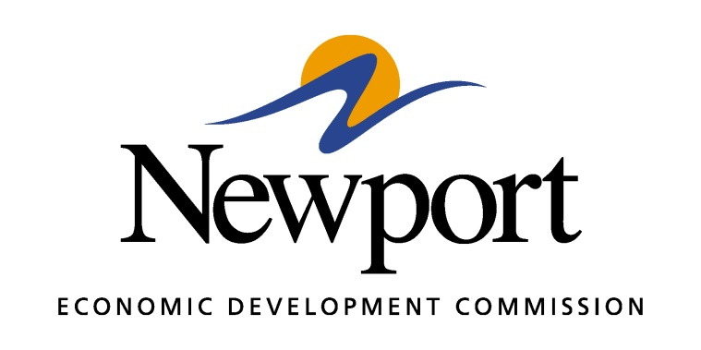

AGENDA
January 11, 2018

Meeting Held at Newport Business Resource Center

- Open Meeting
- Approval of Minutes
- Approval of Financial Report
- Approval of Amended Budget
- Executive Director’s Report
- Director of Chamber Affairs’ Report
- ReNewport Grants
- Cultural Survey Issue
- Competitive Communities Program
- Phone System for the NEDC
- Website
- Adjourn

