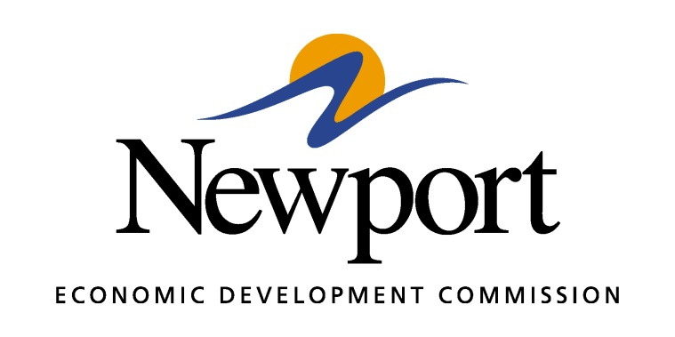

AGENDA
January 11, 2018

Meeting Held at Southwest Steel Processing

- Open Meeting
- Presentation by Southwest Steel Processing
- Approval of Minutes
- Approval of Financial Report
- Executive Director’s Report
- Director of Chamber Affairs’ Report
- ReNewport Grants
- White River Port Grant Match
- Maverick House
  - Roof
  - Fire Suppression System
  - Hot Water Heater
- Marketing Event for AEDC
- Adjourn

