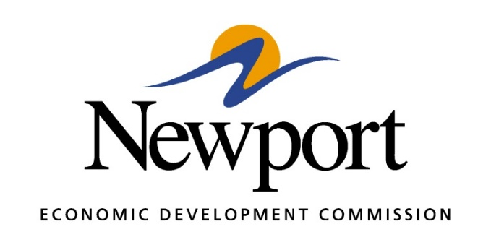

AGENDA
June 8, 2017

- Open Meeting
- Approval of Minutes
- Approval of Financial Report
- Executive Director’s Report
- Director of Chamber Affairs’ Report
- ReNewport Grants
- Jackson County Manufacturing Camp
- ASU-Newport Business Department Survey
- ASU-Newport/Unity Health Proposal
- Prospect Activity
- Rail to Industrial Park
- Mega Site Progress
- Good of the Order
- Adjourn

